Easter Egg Design Competition Entry Form

Name:
Class / Year Group:

Get creative this Easter! Use the template on the back to design your own Easter Egg. Cover it in colourful squiggles, draw your favourite thing, or maybe even a self-portrait!

You can use whatever materials you like, such as crayons, pens, pencils or paint. Think outside the (egg)box - you may like to use felt, glitter pompoms or paper shapes to build up a 3D model!

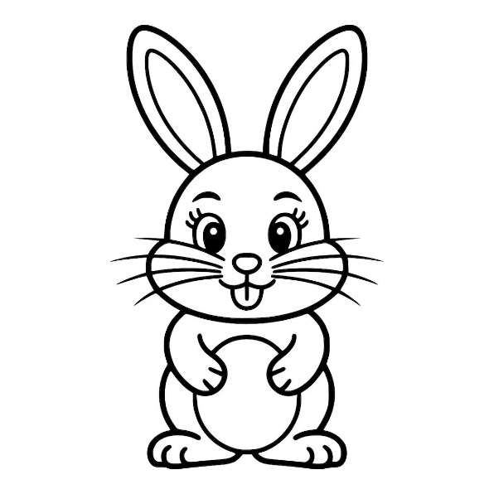
Let your imagination run wild and show us your amazing creations.

Return completed entries to the
Easter Bunny’s
Friends of Beam Competition Entry Post Box
by the end of the school day on
Tuesday 24th March 2026.

Entries will be judged on Wednesday 25th March, with prizes ready for collection from the main reception area on Friday 27th March 2026.

Good luck!
