Performance data – 2024/25

Good Level Of Development

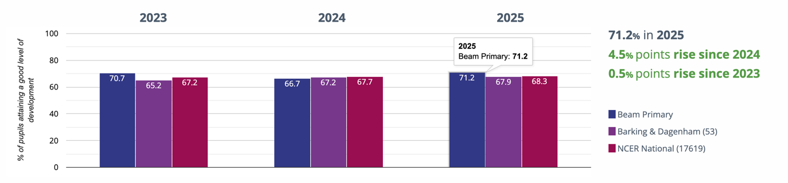

Average number of early learning goals at expected level per child

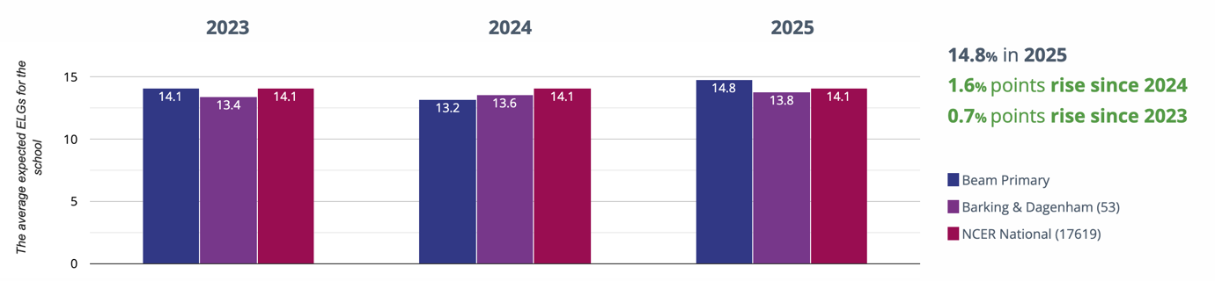

Year 1: Working At
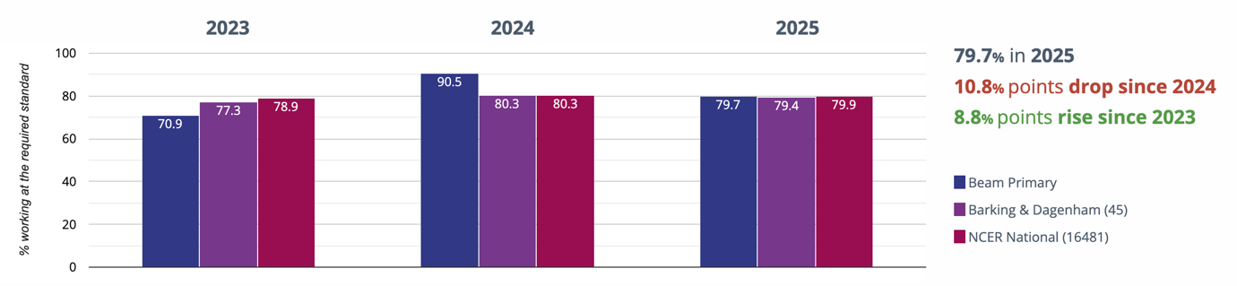
many of the year 1 pupils started quite late in the academic year, therefore there are gaps from their previous schooling. Also, Year 1 (last academic year) has many of the Atlantis pupils as part of the cohort.

 | Phonic score | Entry date | Notes
JB | 0 | 19 May 2025 | K code  Safeguarding
KG | Disapplied | 07 Sept 2022 | K code- Atlantis pupil
SG | Absent | 07 Sept 2023 | K code- was then off rolled 02 June 2025  PP
AG | 7 | 02 Jun 2025 | EAL- ROMA
SG | 29 | 07 Sept 2022 | E code- Atlantis pupil
NJ | 26 | 13 Nov 2023 | EAL  Poor attendance in Reception- 81%  Behaviour issues
JO | Disapplied | 07 Sept 2023 | E code- Atlantis pupil  Safeguarding
LR | Absent | 03 Jul 2025 | Previous school submitted absence mark  Safeguarding
BS | 29 | 30 Jan 2025 | EAL- early acquisition  Poor attendance at previous school- 85%
RS | 23 | 22 Apr 2025 | Poor attendance- 81% at Beam  82% at previous school
HV | 19 | 09 Jun 2025 | Safeguarding  FSM
EV | 20 | 16 Sept 2024 | K code  EAL- early acquisition  PP  FSM
KZ | 26 | 20 Nov 2023 | EAL- early acquisition  was moved classes during Year 1 due to behaviour

Year 2: Working At
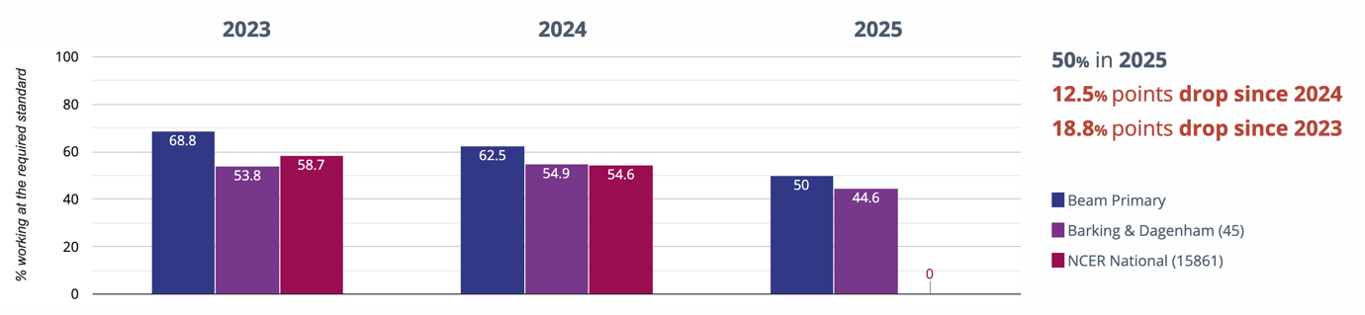
 | Phonic score |  | Entry date | Notes
 | Year 1 | Year 2 | Entry date | Notes
SB | 25 (assessed at another school) | 38 | 03 Feb 2025 | EAL
SD | Disapplied | Disapplied | 19 April 2024 | SEND- Atlantis pupil
AH | Wasn’t at school | 0 | 21 May 2025 | no previous schooling- K code  FSM
AJ | 6 | 19 | 13 Sept 2021 | E code- Apollo pupil
JK | 26 | 32 | 05 Jan 2021 | EAL
MO | 3 | 35 | 05 Sept 2022 | K code  PP  FSM
SO |  | 15 | 01 Oct 2024 | K code- left 02 Jul 2025
NR | 12 | 30 | 06 Mar 2025 | Poor attendance- 78% in Year 1 then  left country for several months and returned
ZR | Didn’t take in Year 1 | 33 | 18 Nov 2024 | E code- Atlantis pupil
JT | 23 | 34 | 20 Sept 2022 | K code  PP  FSM

KS1 Reading - attaining EXS or better

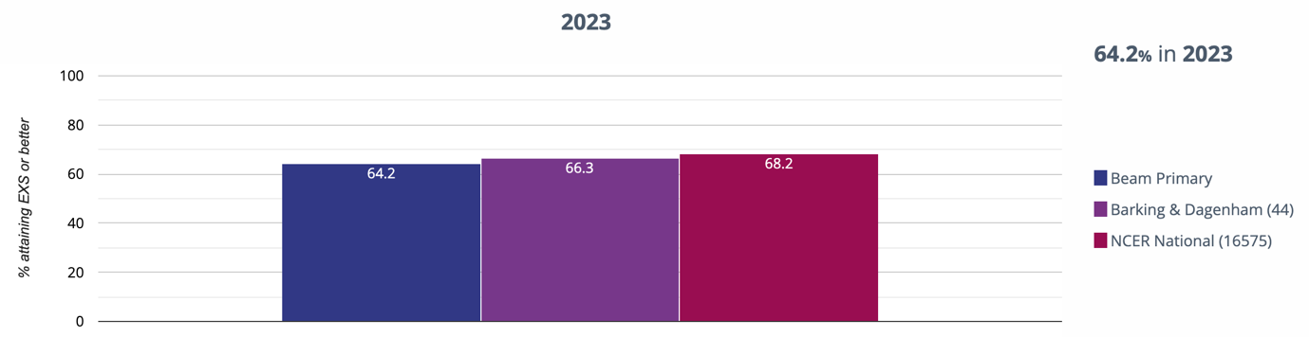

Reading - attaining GDS
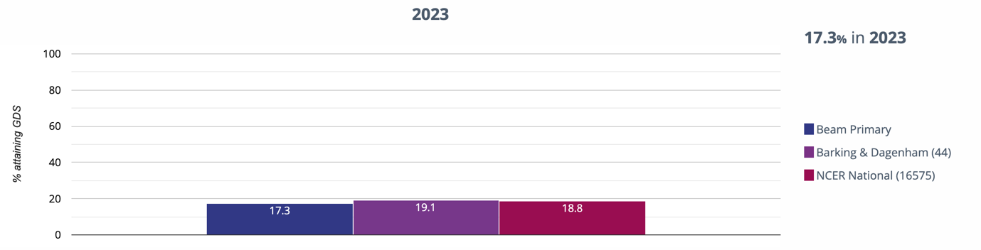

KS2

Reading - achieved standard
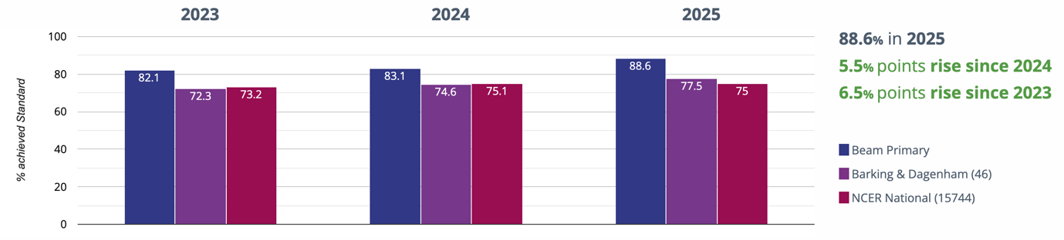

Reading - high attainers
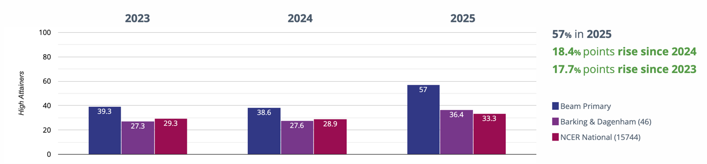

Reading - average scaled score
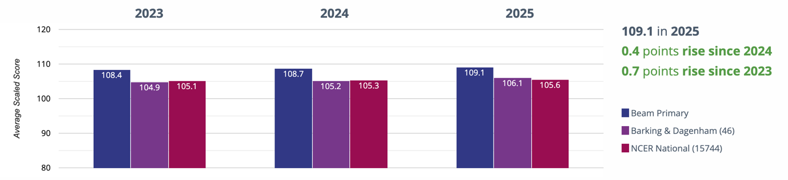

Writing - achieved standard
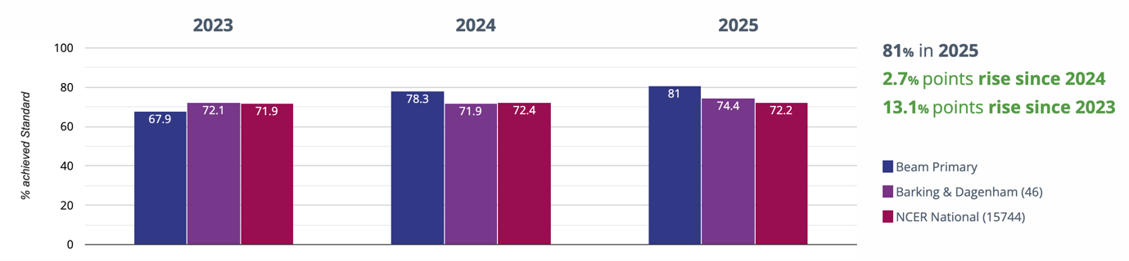

Writing - high attainers
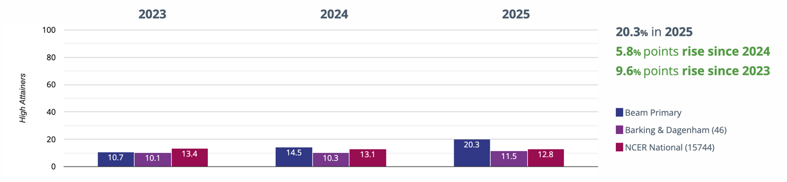

Maths - achieved standard
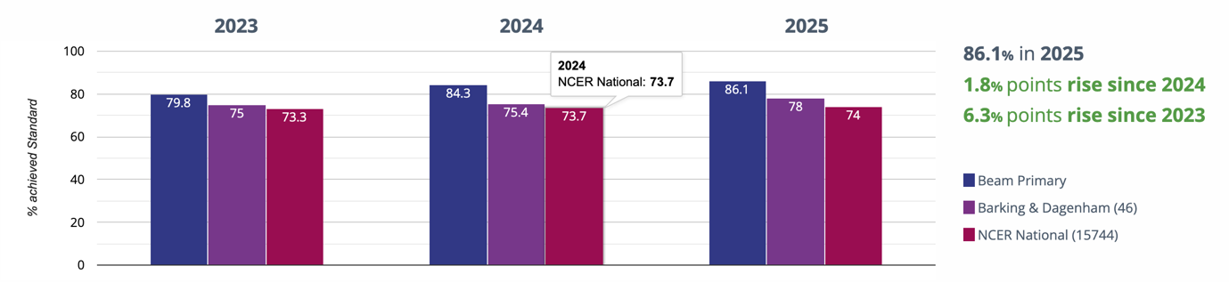

Maths - high attainers
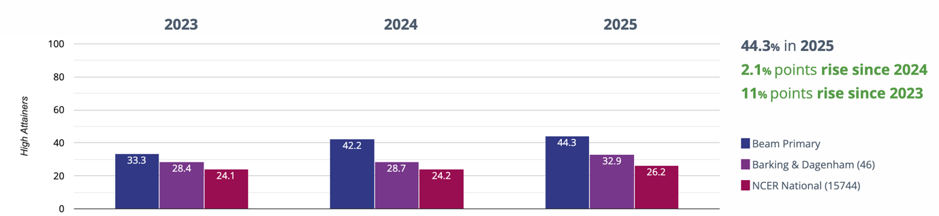

Maths - average scaled score
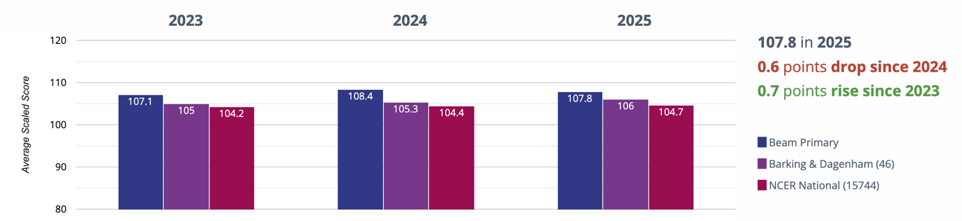

GPS - achieved standard

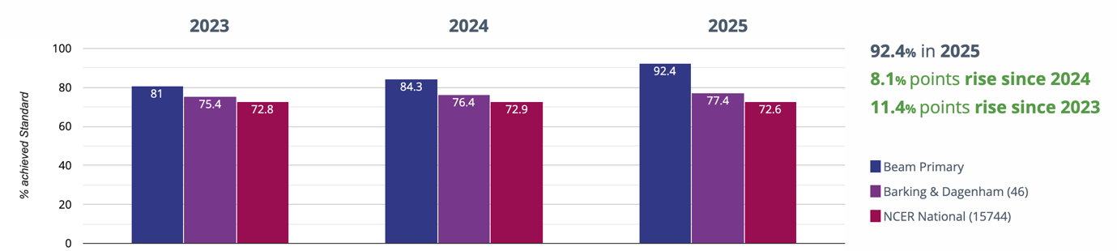

GPS - high attainers

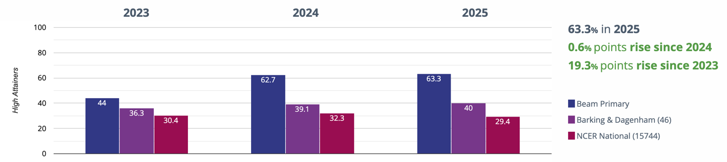

GPS - average scaled score

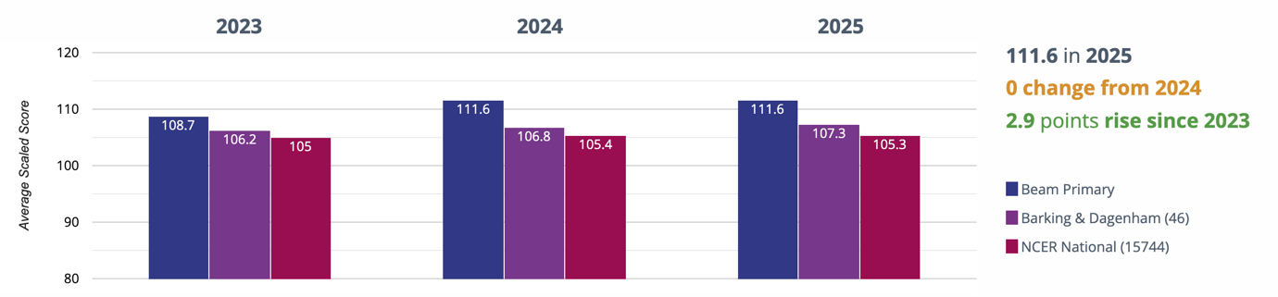

RWM - achieved standard
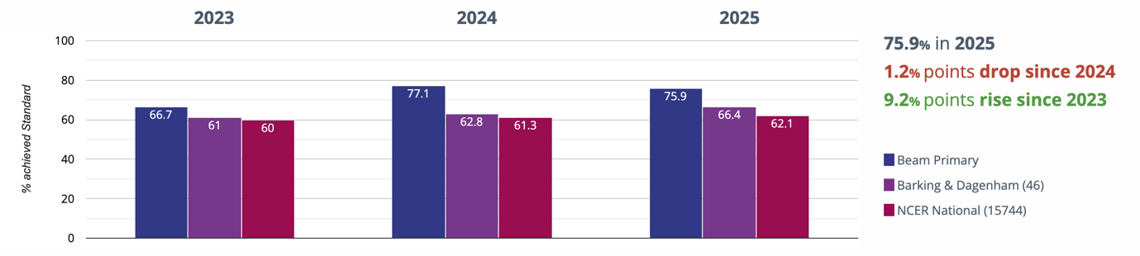

RWM - high attainers

